Experiment Date: 11/02/2019

Date Submitted: 17/02/2019

experiment 4: Film and Drop Condensation (Short Report)

Bethany Mulliner – Group A4

|  |  |
| --- | --- |
| **Topic** | **Page Number** |
| **Title Page** | 1 |
| **Contents Page** | 2 |
| **Results** | 3 |
| **Discussion of Results** | 7 |
| **Appendix I: Example Calculations** | 8 |
| **References** | 11 |

**Contents**

**Results**

Note: Where physical constants have been unavailable in the literature, they have been interpolated using known values. An example for this procedure is provided in the Appendix.

200ml of condensate was collected during each run of the experiment.

Ri was assumed to be negligible.

All physical constants are obtained from Perry’s unless otherwise specified. [1]

Temperature Key (All ˚C)

T1 – Top Tube Cold Water Inlet Temperature

T2 – Top Tube Cold Water Outlet Temperature

T3 – Top Tube Steam Inlet Temperature

T4 – Top Tube Steam Outlet Temperature

T5 – Bottom Tube Cold Water Inlet Temperature

T6 – Bottom Tube Cold Water Outlet Temperature

T7 – Bottom Tube Steam Inlet Temperature

T8 – Bottom Tube Steam Outlet Temperature

Filmwise Condensation

Collected Results

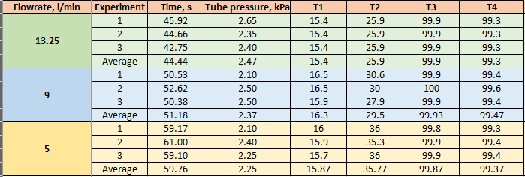

Data from Literature and hence Derived Results

Tube length – 0.914m

Tube outer diameter – 0.0191m

Tube inner diameter – 0.0159m

Tube material – Brass [2]

Tube cross-sectional area – 0.0457m2

Tube wall thickness – 0.0016m

Conductivity of brass – 104W/mK [3]

Acceleration due to gravity – 9.807m/s2

Steam enthalpy values from steam tables. [4]

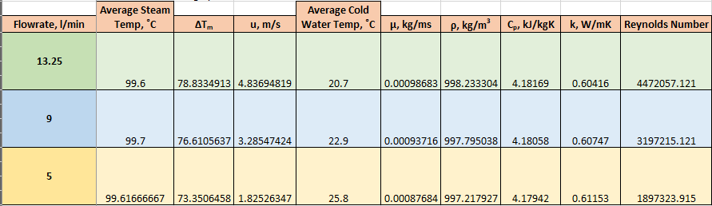

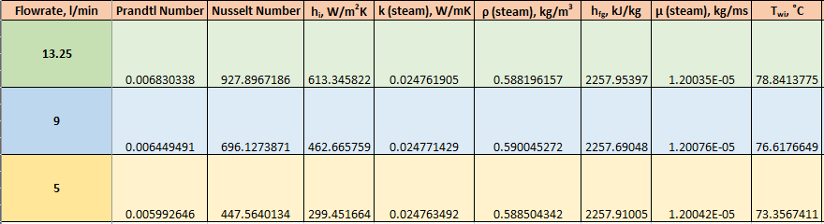

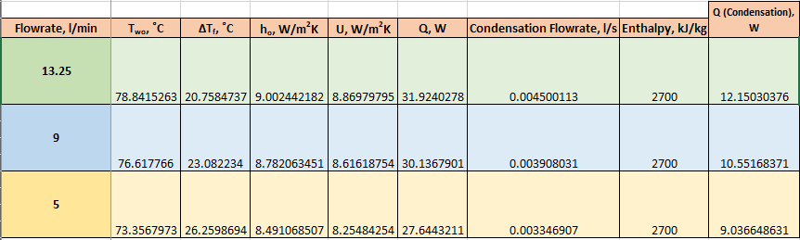

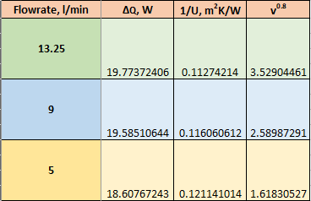

[5]

Dropwise Condensation

Collected Results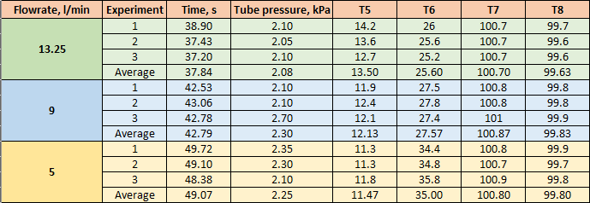

Data from Literature and hence Derived Results

Tube length – 0.914m

Tube outer diameter – 0.0191m

Tube inner diameter – 0.0159m

Tube material – Brass [2]

Tube cross-sectional area – 0.0457m2

Tube wall thickness – 0.0016m

Conductivity of brass – 104W/mK [3]

Acceleration due to gravity – 9.807m/s2

Steam enthalpy values from steam tables. [4]

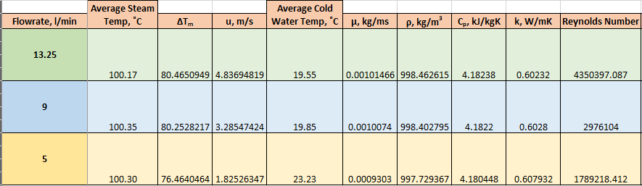

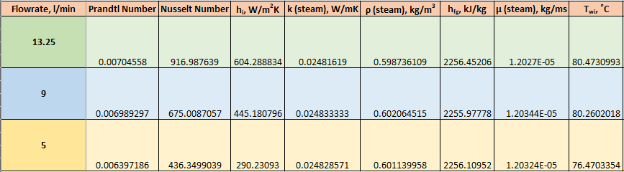

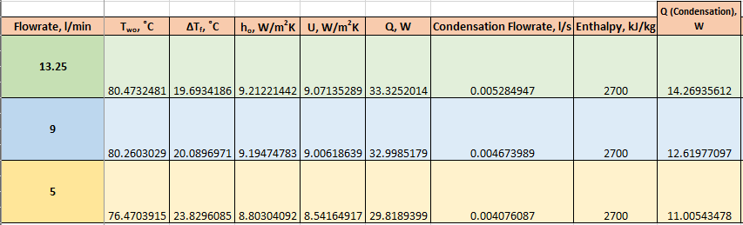

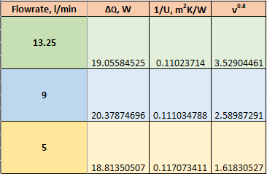

[5]

**Discussion of Results**

The aim of the experiment was to gain a better understanding of condensation through comparing the overall heat transfer coefficients obtained under filmwise and dropwise conditions. By recording the time taken for a set amount of condensate to be collected at a constant cold-water flowrate and steam pressure and the various temperature throughout the system, along with using physical constants from literature, the overall heat transfer coefficients and hence the heat flux for the different tubes at different flowrates could be calculated. [2]

For the tube experiencing filmwise condensation, the plotted Wilson chart shows a clear strong linear relationship between the overall heat transfer coefficient and the fluid velocity. In filmwise condensation, a film always covers the surface of the condenser. As the velocity of the cold water increases, one would expect heat transfer to be less effective, and this is clearly shown on the Wilson chart. For the tube experiencing dropwise condensation, the plotted Wilson chart also shows a clear strong linear relationship between the overall heat transfer coefficient and the fluid velocity, albeit with some subtle differences to the filmwise condensation Wilson chart. In dropwise condensation, discrete vapour droplets continuously condense and drop from the surface of the condenser, causing the surface to be continuously exposed. Once again, the velocity of the cold water increases, one would expect heat transfer to be less effective, and this is clearly shown on the Wilson chart. However, the correlation is not as strong as that displayed by the Wilson chart for filmwise condensation. This is likely due to the oleic acid, which was applied to the pipe to promote dropwise condensation, becoming ineffective due to slowly coming off the pipe through normal use.

From the results, it can be observed that the values for heat flux were higher for dropwise condensation compared to those for filmwise condensation, at the same flowrates. This is because the film that forms over the pipe during filmwise condensation is a relatively poor conductor of heat, creating more thermal resistance and reducing the heat flux. [6]

It can also be observed that the theoretical heat transferred through condensation does not match the expected values for that of the collected condensate. This is likely due to unavoidable heat losses due to the steam mixing with small amounts of air. [6] Another issue that was experienced was the difficulty in controlling both the cold water flowrate and especially the tube pressure. As a result of this, obtaining results that were at a perfectly constant pressure and flowrate was almost impossible, despite best efforts to do so. This could have caused some results to become inaccurate or misleading. Our collected values for overall heat coefficient were also somewhat lower than expected, as values in the range of 20-300 are more usual for the conditions of the experiment. [7] This could be due to an unknown fouling factor having an effect on the heat transfer. [8]

In conclusion, it was found that dropwise condensation gives higher values for heat transfer coefficients and hence heat flux than filmwise condensation. It was also found that the energy of the system was not balanced due to heat loss due to an unknown factor, but possibly due to the steam being partially mixed with incondensable air. An unknown fouling factor may also have had an effect on the experiments, as the heat transfer coefficients were far lower than expected, however, the expected relationship between heat flux and cold-water velocity was obtained for both experiments. [2]

**Appendix I: Example Calculations**

Area of Heat Transfer

$$A=πd_{i}l$$

$$A=π×0.0159×0.914=0.0457m^{2}$$

ΔTm

[2]

Where:

TS – Average steam temperature

TI – Temperature at cooling water inlet

TO – Temperature at cooling water outlet

$$∆T_{m}=\frac{\left(100.17-25.6\right)-\left(100.17-13.5\right)}{\ln\left(\frac{100.17-25.6}{100.17-13.5}\right)}=80.465$$

Fluid Velocity

$$u=\frac{Flowrate,\frac{l}{s}}{CSA, m^{2}}$$

Interpolation of Physical Constants

Interpolating between two values, say xa and xb, with corresponding data ya and yb to find the value of y for a known x is given as:

$$y= y_{a}+(y_{b}-y_{a})\frac{x-x_{a}}{x_{b}-x_{a}}$$

[9]

This was used to find values of viscosity, density, specific heat capacity, thermal conductivity, hf and hg for water and for steam. For example:

$$y= 999.000999+\left(998.003992-999.000999\right)\frac{292.7-290}{295-290}=998.462615$$

Reynolds Number

$$Re= \frac{ρud}{μ}$$

[10]

$$Re= \frac{998.462615×4.83694819×0.914}{0.00101466}=4350397.087$$

Prandtl Number

$$\operatorname{Pr}{= \frac{C_{p}μ}{k}}$$

[10]

$$\operatorname{Pr}{= \frac{4.18238×0.00101466}{0.60232}=0.00704558}$$

Nusselt Number

$$Nu=0.023{Re}^{0.8}{Pr}^{0.33}$$

[2]

$$Nu=0.023×{4350397.087}^{0.8}×{0.00704558}^{0.33}=916.987639$$

Inside Film Transfer Coefficient

$$h_{i}=\frac{Nuk}{d}$$

[10]

$$h_{i}=\frac{916.987639×0.60232}{0.914}=604.288834Wm^{-2}K^{-1}$$

hfg

Mean Inside Wall Temperature

$$T_{wi}=\frac{u}{h_{i}}+{∆T}_{m}$$

[2]

$$T_{wi}=\frac{4.83694819}{604.288837}+80.4650949=80.4730993°C$$

Mean Outside Wall Temperature

$$T_{wo}=\frac{x_{w}u}{k_{w}}+T_{wi}$$

[2]

$$T_{wo}=\frac{0.0016×4.83694819}{104}+80.4730993=80.473˚C$$

Condensate Film Temperature Difference

$${∆T}_{f}=T_{S}-T_{wo}$$

[2]

$${∆T}_{f}=100.17-80.473=19.693℃$$

Outside Film Transfer Coefficient

$$h_{o}=0.72{\left(\frac{k^{3}ρ^{2}gh_{fg}}{d_{o}μ∆T_{f}}\right)}^{\frac{1}{4}}$$

[2]

$$h_{o}=0.72{\left(\frac{{0.02481619}^{3}×{0.598736109}^{2}×9.87×2256.45206}{0.0191×1.2027×{10}^{-5}×19.693493}\right)}^{\frac{1}{4}}=9.21220572Wm^{-2}K^{-1}$$

Overall Heat Transfer Coefficient

$$U={\left(\frac{1}{h_{o}}+\frac{x_{w}}{k_{w}}+\frac{1}{h_{i}}\right)}^{-1}$$

[2]

$$U={\left(\frac{1}{9.21220572}+\frac{0.0016}{104}+\frac{1}{604.288834}\right)}^{-1}=9.07261061Wm^{-2}K^{-1}$$

Heat Transferred

$$Q=UA∆T_{m}$$

[2]

$$Q=9.07261061×0.0457×80.4650949=33.3298218W$$

Condensate Heat

$$Q=Enthalpy×Flowrate$$

$$Q=0.005284947×2700=14.269359616W$$

**References**

|  |  |
| --- | --- |
| [1] | R. H. Perry and D. W. Green, “Table 2-352 Saturated Water Substance-Temperature (SI Units),” in *Perry's Chemical Engineer's Handbook (Seventh Edition)*, New York, McGraw-Hill, 1997, pp. 2-306 - 2-307. |
| [2] | Heriot-Watt University School of Engineering & Physical Sciences, Film and Drop Condensation, Edinburgh: Heriot-Watt University, 2006. |
| [3] | R. Sinnott and G. Towler, “TABLE 12.6. Conductivity of Metals,” in *Chemical Engineering Design (Fifth Edition)*, Oxford, Elsevier, 2017, p. 845. |
| [4] | Heriot-Watt University, “Temperature - Pressure - Enthalpy Diagram for Steam,” in *Steam Tables*, Edinburgh, Heriot-Watt University, p. 11. |
| [5] | D. Wilkie, “Wilson Plot,” Thermopedia, 2 February 2011. [Online]. Available: http://www.thermopedia.com/content/1262/. [Accessed 14 February 2019]. |
| [6] | S. Pandey, “Dropwise and filmwise condensation,” *International Journal of Scientific & Engineering Research,* vol. 3, no. 4, 2012. |
| [7] | R. Sinnott and G. Towler, “TABLE 12.1. Typical Overall Coefficients,” in *Chemical Engineering Design*, Oxford, Elsevier, 2017, pp. 819-820. |
| [8] | R. H. Perry and D. W. Green, “Heat Transfer With Change of Phase,” in *Perry's Chemical Engineers' Handbook (Seventh Edition)*, New York, McGraw-Hill, 1997, pp. 5-20 - 5-23. |
| [9] | D. M. Himmelblau and J. B. Riggs, “Example 16.2 Interpolating in the Steam Tables,” in *Basic Principles and Calculations in Chemical Engineering (International Seventh Edition)*, Upper Saddle River, Prentice Hall Professional Technical Reference, 2004, pp. 491-492. |
| [10] | J. Coulson and J. Richardson, “Heat Transfer in Reaction Vessels,” in *Chemical Engineering Volume One*, London, Pergamon Press, 1954, pp. 200-205. |